Project Plan

SE Group 14

*Abdalla Shita*

*Alex Sinclair*

*Dion Upton*

*Jaimie Witherspoon*

*Jamie*

Plan outline

Our project plan was discussed in the first week and on the second week a small plan was made to separate the work between our team members. The plan was 10 weeks long, as it’s shown in the figure below

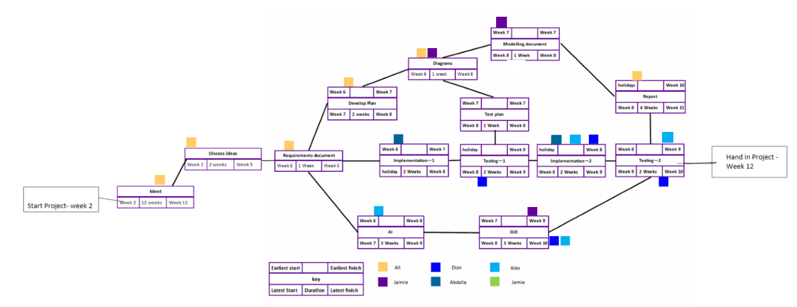

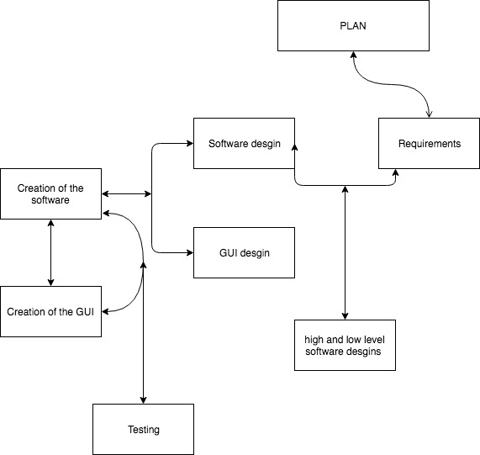

Week 2 and week 3 – Project plan

The first two weeks were dedicated to create a general class diagram for our program and a plan for later on weeks. This was done by all of the team members. The class diagram was important so it could help all team members to have a rough idea on how our game would work. On week two Jamie would create a GitHub page and add all of the team members in order to have access to all of the work and make less confusion.

Week 4 and week 5 – Documentation

In week 4 and 5 all of the team member would be working on writing up one of the first task which is making a set of requirements. This would determine what exactly our program should do. The second task was providing appropriate software design with some combination of high and low level design this would be expressed by using few diagrams. The second task was assigned to Alex, Abdalla …. I don’t remember how else helped us in this.

Week 6 and week 7 – software creation

For week 6 and 7 Abdalla will start writing up the code by following the design requirements (the class diagram that we made and agreed on). Alex will start creating the AI (bot) for the game.

Jamie and Jamie and Dion will keep working on the requirements and the making of some high and low level diagram designs. Jamie would help Abdalla in writing up the code if any problem occurs or for advice as Jaimie is following most of the team work.

Week 8 – Testing

Week 8 is dedicated mainly for testing the software in order for the software to be bug-less and more efficient. The testing part would be done by Alex. Jaimie would be finishing most of the diagrams. Dion will start working on the GUI. Jaimie would help in preparing the needed images for the GUI. By the end of the week our team would need to meet and make sample design of GUI

Week 9 – GUI Creation

In week 9, Dion would be working on the GUI while Alex will try to integrate it later on with the existing software. For the design of GUI Dion will follow the planned GUI. The other three members will focus on finishing the previous tasks and prepare of the final stage.

Week 10– GUI testing

The main focus of this week is testing the GUI testing. The testing will involve us playing the game and record the bugs which will be found. Secondly the team will try to fix each bug and create a similar scenario to re-test the new implementations and make sure the bug will not accrue again.

Week 11 – Final Documentations + last review

For the final week the team will be having a final look on the project and fix any possible problems. This will involve reviewing the documentations, missing documentation and the performance of the GUI and the software.